**Roll No:** 4065

**Name:** Hamza Quraish

**Bug Report**

**Site:** [**http://demo.vuestorefront.io/**](http://demo.vuestorefront.io/)

**Bug Id:** 01

**Title:** “Help & FAQs”link is not working in the navigation bar on homepage.

**Reporting Date:** 24/07/2022

**Reporter:** Hamza Quraish

**Test Item:** Help & FAQs link

**Test Environment:** All Browsers/QA environment

**Description:**

**Steps to reproduce:**

* Open [**http://demo.vuestorefront.io/**](http://demo.vuestorefront.io/)
* Click on “help & FAQs” link on the navigation bar

**Test Data Used:**

* Just click on the “Help & FAQs” link

**Expected Result: “**Help & FAQs” page is opened according to the clicked linked.

**Actual Result: “**Help & FAQs” page is not opening after clicking on Help & FAQs link.

**Severity:** Low

**Priority:** High

**Frequency:** Every time

**Status:** New

**Attachments:** 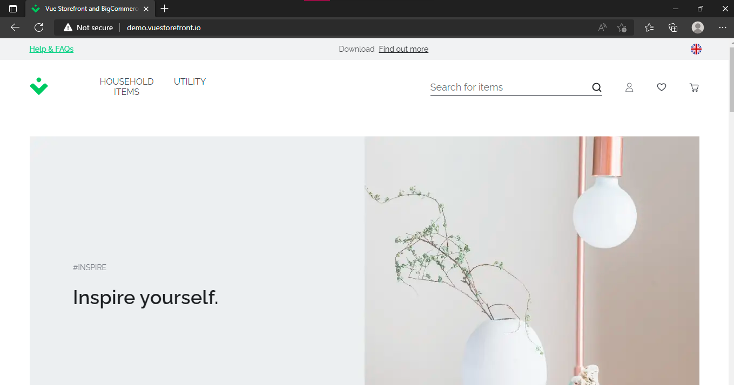

**Bug Id:** 02

**Title:** “Find out more”link is not working in the navigation bar on homepage.

**Reporting Date:** 24/07/2022

**Reporter:** Hamza Quraish

**Test Item: “**Find out more” link

**Test Environment:** All Browsers/QA Environment

**Description:**

**Steps to reproduce:**

* Open [**http://demo.vuestorefront.io/**](http://demo.vuestorefront.io/)
* Click on “Find out more” link on the navigation bar

**Test Data Used:**

* Just click on the “Find out more” link

**Expected Result: “**Find out more” page is opened according to the clicked link.

**Actual Result: “**Find out more” page is not opening after clicking on Help & FAQs link.

**Severity:** High

**Priority:** High

**Frequency:** Every time

**Status:** New

**Attachments:**

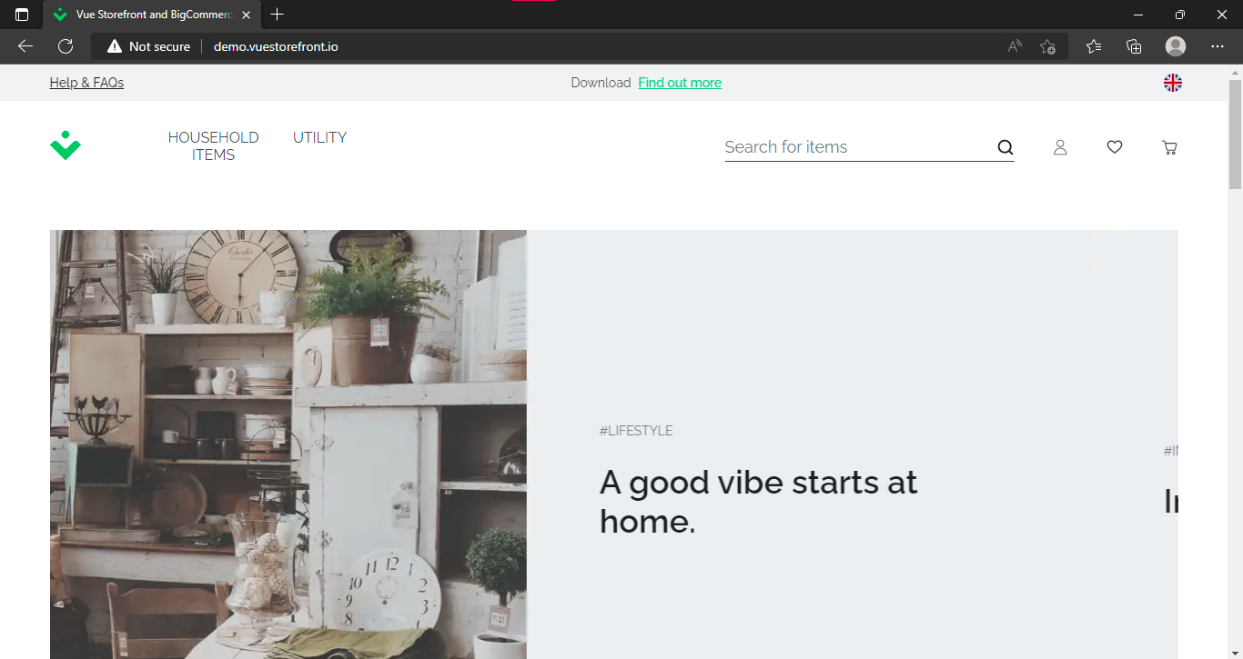

**Bug Id:** 03

**Title:** Not all the text is translated to German by selecting German language in the navigation bar on homepage.

**Reporting Date:** 24/07/2022

**Reporter:** Hamza Quraish

**Test Item:** Language Selector

**Test Environment:** All Browsers/QA Environment

**Description:**

**Steps to reproduce:**

* Open [**http://demo.vuestorefront.io/**](http://demo.vuestorefront.io/)
* Click on language button on the navigation bar
* Then click on German language in choose language option

**Test Data Used:**

* Just click on the language button

**Expected Result:** All the text on site should be translated to German.

**Actual Result:** Some of the site text is not translated to German.

**Severity:** High

**Priority:** High

**Frequency:** Every time

**Status:** New

**Attachments:** 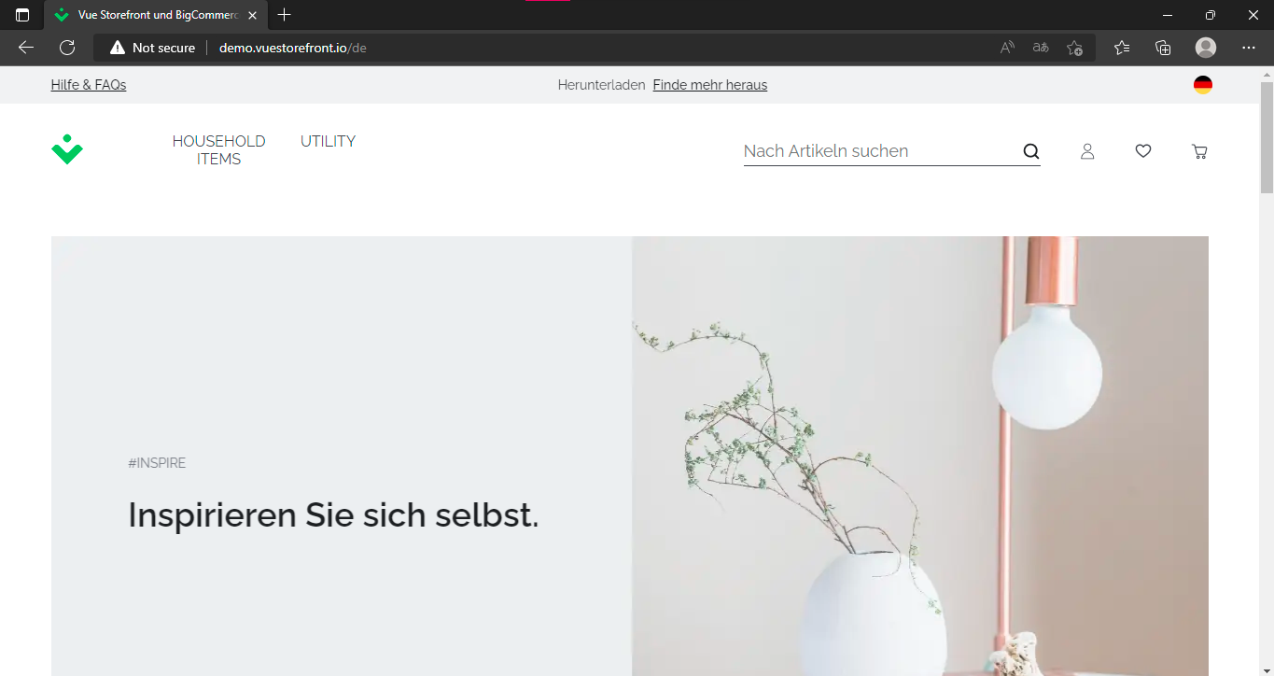

**Bug Id:** 04

**Title:** The color of close button on language selector is green.

**Reporting Date:** 24/07/2022

**Reporter:** Hamza Quraish

**Test Item:** Close button on language Selector

**Test Environment:** All Browsers/QA Environment

**Description:**

**Steps to reproduce:**

* Open [**http://demo.vuestorefront.io/**](http://demo.vuestorefront.io/)
* Click on language button on the navigation bar
* Then click on close button in language option

**Test Data Used:**

* Just click on close button

**Expected Result:** The color of the close button should be red.

**Actual Result:** The color of the close button is green.

**Severity:** low

**Priority:** low

**Frequency:** Every time

**Status:** New

**Attachments:**

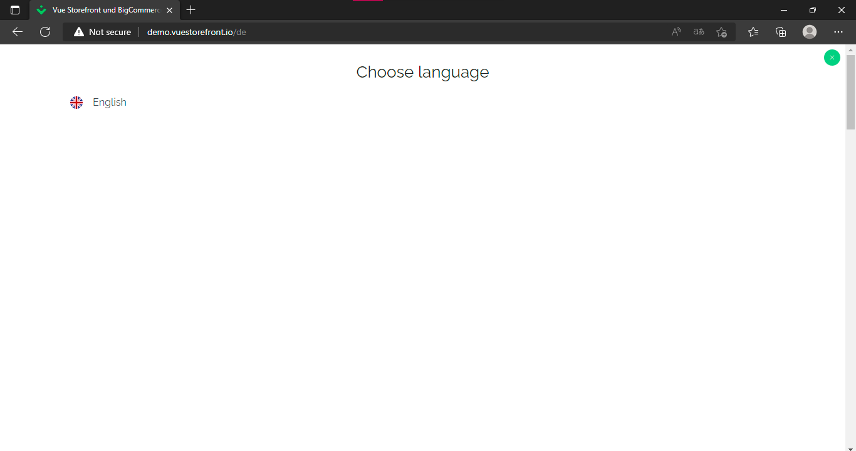

**Bug Id:** 05

**Title:** There is a scroll bar on right side of language selector although there’s only one language to select.

**Reporting Date:** 24/07/2022

**Reporter:** Hamza Quraish

**Test Item:** Language Selector

**Test Environment:** All Browsers/QA Environment

**Description:**

**Steps to reproduce:**

* Open [**http://demo.vuestorefront.io/**](http://demo.vuestorefront.io/)
* Click on language button on the top right of the navigation bar
* Click to Scroll in the language selector option

**Test Data Used:**

* Just scroll on the page

**Expected Result:** There should not be a scroll in language selection option

**Actual Result:** There is a scroll in the language selector option.

**Severity:** low

**Priority:** high

**Frequency:** Every time

**Status:** New

**Attachments:** 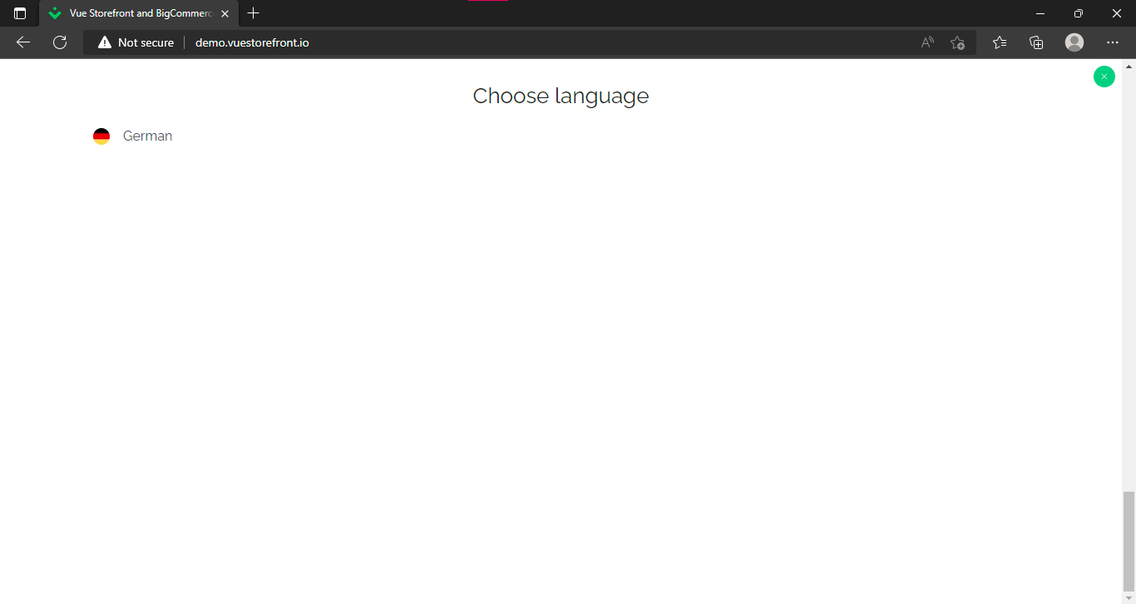

**Bug Id:** 06

**Title:** Logo button is not working on homepage

**Reporting Date:** 24/07/2022

**Reporter:** Hamza Quraish

**Test Item:** Logo

**Test Environment:** All Browsers/QA Environment

**Description:**

**Steps to reproduce:**

* Open [**http://demo.vuestorefront.io/**](http://demo.vuestorefront.io/)
* Click on the logo on homepage

**Test Data Used:**

* Just click on the logo

**Expected Result:** By clicking on the logo homepage should open up.

**Actual Result:** Logo button is not working on homepage.

**Severity:** High

**Priority:** High

**Frequency:** Every time

**Status:** New

**Attachments:** 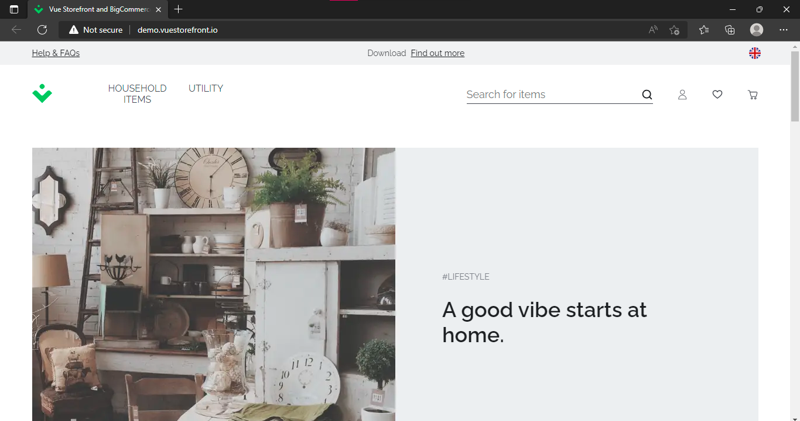

**Bug Id:** 07

**Title:** Profile button on first click opens sign up page and login page on the rest of the clicks

**Reporting Date:** 24/07/2022

**Reporter:** Hamza Quraish

**Test Item:** Profile Button

**Test Environment:** All Browsers/QA Environment

**Description:**

**Steps to reproduce:**

* Open [**http://demo.vuestorefront.io/**](http://demo.vuestorefront.io/)
* Click on the profile button on homepage
* Click on close button
* Then again click on profile button

**Test Data Used:**

* Just click on the profile button

**Expected Result:** By clicking on the profile button login page should open up.

**Actual Result:** Signup page opens up on first click on the profile button and login page opens up on the rest of the clicks.

**Severity:** High

**Priority:** High

**Frequency:** Every time

**Status:** New

**Attachments:**

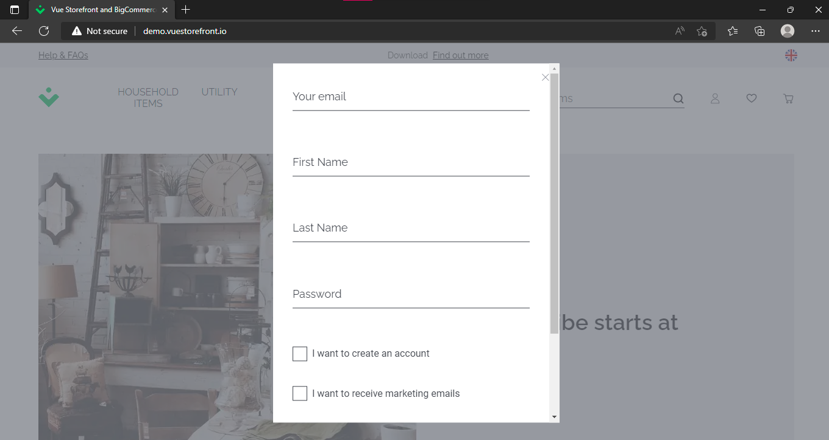

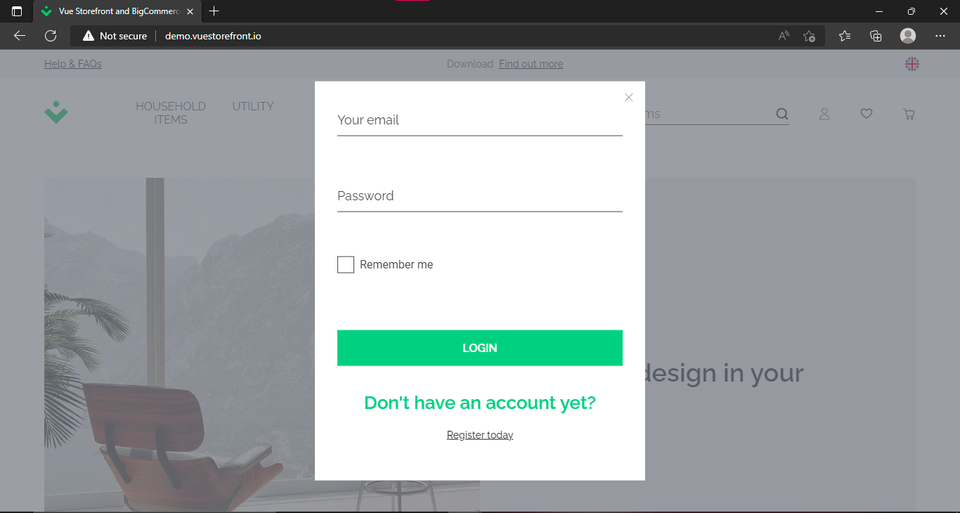

**Bug Id:** 08

**Title:** First name field in signup form is accepting numbers and special characters as input.

**Reporting Date:** 24/07/2022

**Reporter:** Hamza Quraish

**Test Item:** First Name field

**Test Environment:** All Browsers/QA Environment

**Description:**

**Steps to reproduce:**

* Open [**http://demo.vuestorefront.io/**](http://demo.vuestorefront.io/)
* Click on the profile button on homepage
* Then click on register today
* Then again click on profile button
* Then click on first name field
* Enter test data

**Test Data Used:** %66%$*

**Expected Result:** First name field should accept only alphabets.

**Actual Result:** First name field is accepting Numbers and special characters as well.

**Severity:** High

**Priority:** High

**Frequency:** Every time

**Status:** New

**Attachments:** 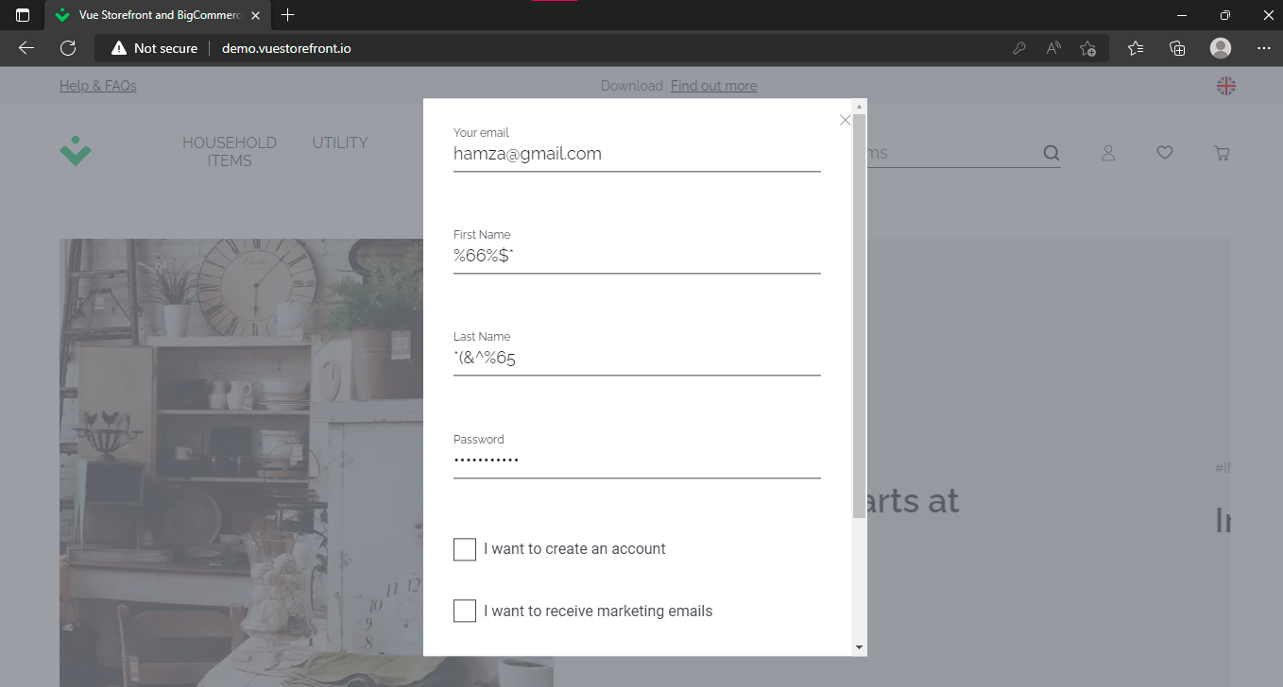

**Bug Id:** 09

**Title:** Last name field in signup form is accepting numbers and special characters as input.

**Reporting Date:** 24/07/2022

**Reporter:** Hamza Quraish

**Test Item:** Last name field

**Test Environment:** All Browsers/QA Environment

**Description:**

**Steps to reproduce:**

* Open [**http://demo.vuestorefront.io/**](http://demo.vuestorefront.io/)
* Click on the profile button on homepage
* Then click on register today
* Then again click on profile button
* Then click on last name field
* Enter test data

**Test Data Used:** *(&^%65

**Expected Result:** Last name field should accept only alphabets.

**Actual Result:** Last name field is accepting Numbers and special characters as well.

**Severity:** High

**Priority:** High

**Frequency:** Every time

**Status:** New

**Attachments:**



**Bug Id:** 10

**Title:** Profile button not working after signing up.

**Reporting Date:** 24/07/2022

**Reporter:** Hamza Quraish

**Test Item:** Profile button

**Test Environment:** All Browsers/QA Environment

**Description:**

**Steps to reproduce:**

* Open [**http://demo.vuestorefront.io/**](http://demo.vuestorefront.io/)
* Click on the profile button on homepage
* Then click on register today
* Enter all required fields
* Then click on create an account, homepage will open up
* After that click on profile button on homepage

**Test Data Used:**

**Expected Result:** Profile menu should open up.

**Actual Result:** Nothing happens on clicking profile button.

**Severity:** High

**Priority:** High

**Frequency:** Every time

**Status:** New

**Attachments:** 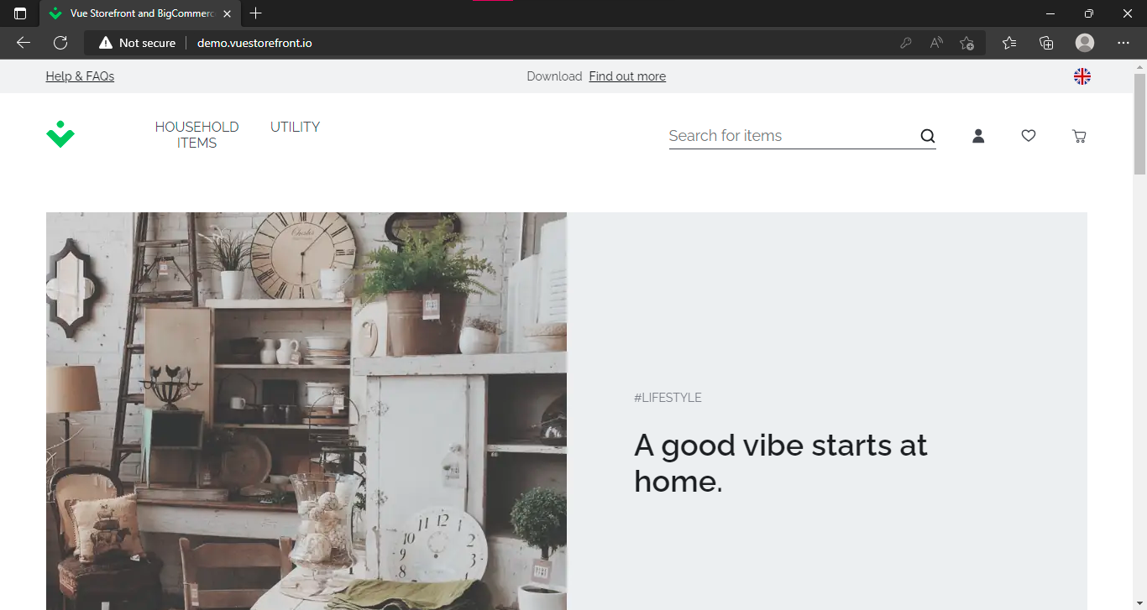

**Bug Id:** 11

**Title:** Login page not working after entering valid credentials.

**Reporting Date:** 24/07/2022

**Reporter:** Hamza Quraish

**Test Item:** Login page

**Test Environment:** All Browsers/QA Environment

**Description:**

**Steps to reproduce:**

* Open [**http://demo.vuestorefront.io/**](http://demo.vuestorefront.io/)
* Click on the profile button on homepage
* Then click on Login
* Enter valid email
* Enter Valid password
* Click on login button

**Test Data Used:**

* Email: [hamza@gmail.com](mailto:hamza@gmail.com)
* Password: hamza@123

**Expected Result:** User should be logged in after entering valid credentials on login page.

**Actual Result:**  User not logged in after entering valid credentials.

**Severity:** High

**Priority:** High

**Frequency:** Every time

**Status:** New

**Attachments:**

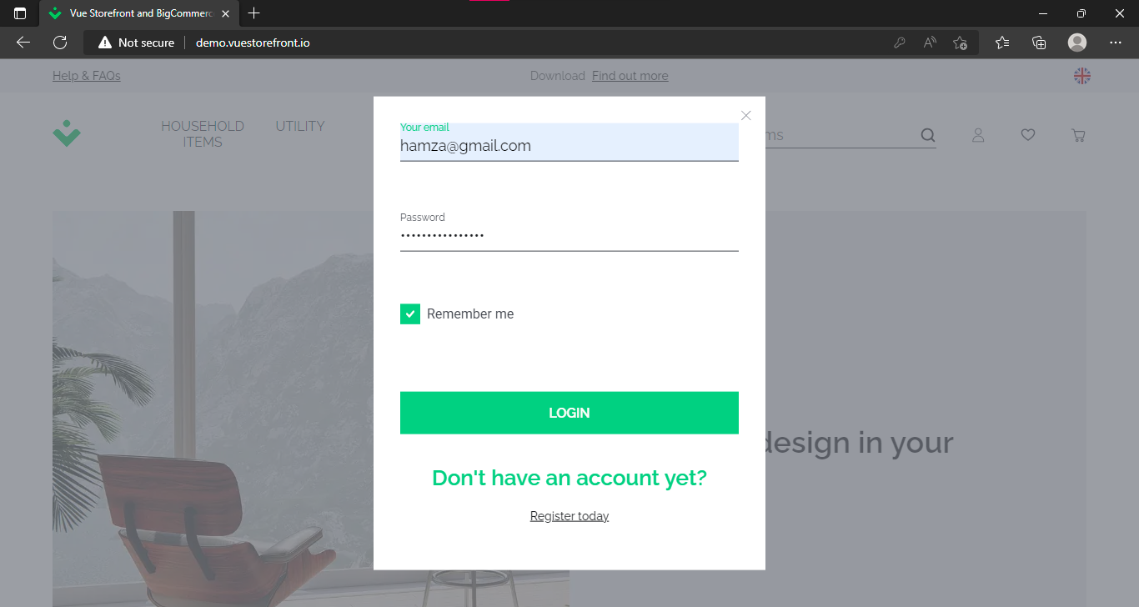

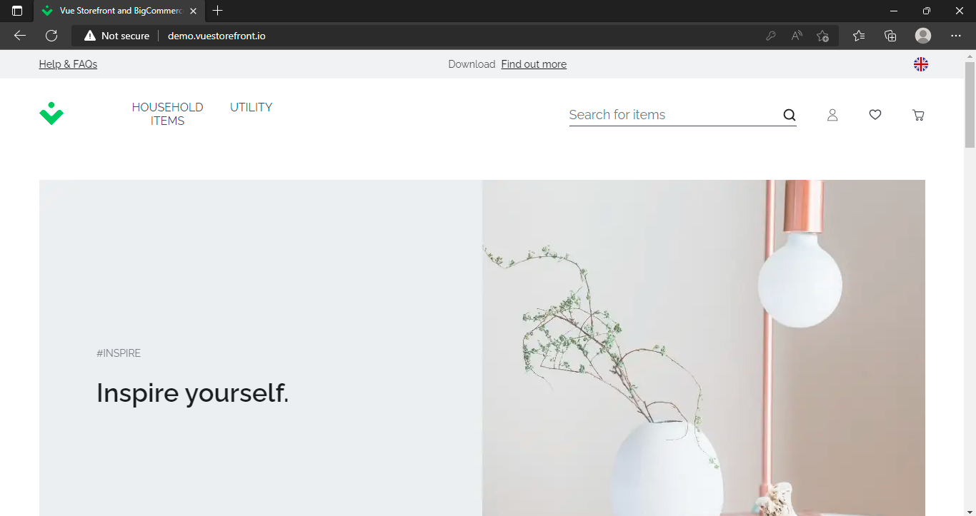

**Bug Id:** 12

**Title: “**Who we are” link is not working in “About us” in footer section.

**Reporting Date:** 24/07/2022

**Reporter:** Hamza Quraish

**Test Item:** Who we are link

**Test Environment:** All Browsers/QA Environment

**Description:**

**Steps to reproduce:**

* Open [**http://demo.vuestorefront.io/**](http://demo.vuestorefront.io/)
* Go to the footer of the page
* Click on “Who we are” link Below About Us

**Test Data Used:**

**Expected Result:** Who we are page should open up.

**Actual Result:** Nothing happens on clicking “Who we are” link

**Severity:** Low

**Priority:** High

**Frequency:** Every time

**Status:** New

**Attachments:** 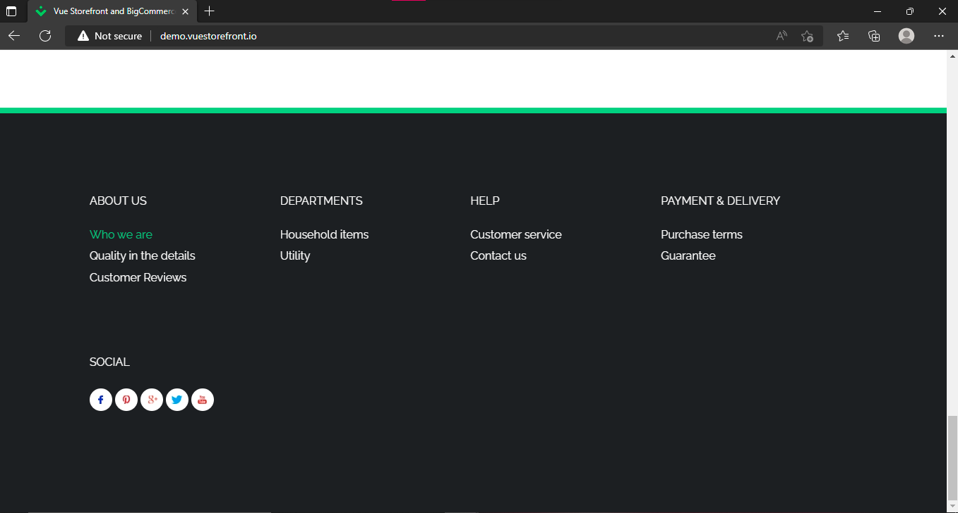

**Bug Id:** 13

**Title: “**Quality in the details” link is not working in “About us” in footer section.

**Reporting Date:** 24/07/2022

**Reporter:** Hamza Quraish

**Test Item:** Quality in the details link

**Test Environment:** All Browsers/QA Environment

**Description:**

**Steps to reproduce:**

* Open [**http://demo.vuestorefront.io/**](http://demo.vuestorefront.io/)
* Go to the footer of the page
* Click on “Quality in the details” link Below About Us

**Test Data Used:**

**Expected Result:** Quality in the details page should open up.

**Actual Result:** Nothing happens on clicking “Quality in the details” link

**Severity:** Low

**Priority:** High

**Frequency:** Every time

**Status:** New

**Attachments:** 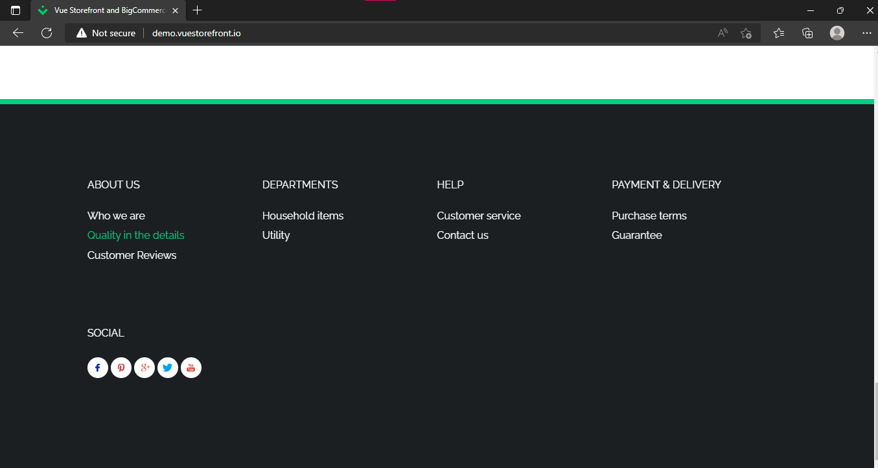

**Bug Id:** 14

**Title: “**Customer Reviews” link is not working in “About us” in footer section.

**Reporting Date:** 24/07/2022

**Reporter:** Hamza Quraish

**Test Item:** Customer Reviews link

**Test Environment:** All Browsers/QA Environment

**Description:**

**Steps to reproduce:**

* Open [**http://demo.vuestorefront.io/**](http://demo.vuestorefront.io/)
* Go to the footer of the page
* Click on “Customer Reviews” link Below About Us

**Test Data Used:**

**Expected Result:** Customer Reviews page should open up.

**Actual Result:** Nothing happens on clicking “Customer Reviews” link

**Severity:** High

**Priority:** High

**Frequency:** Every time

**Status:** New

**Attachments:**

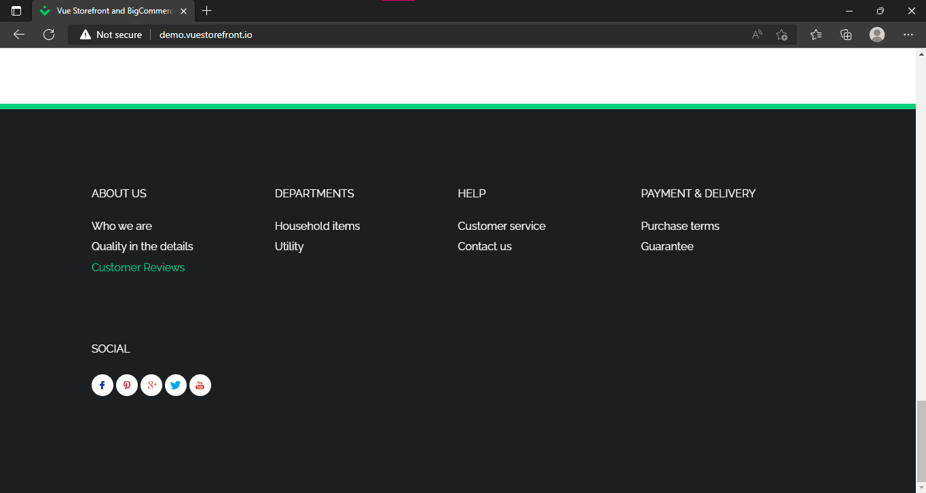

**Bug Id:** 15

**Title: “**Household Items” link is not working in “Departments” in footer section.

**Reporting Date:** 24/07/2022

**Reporter:** Hamza Quraish

**Test Item:** Household Items link

**Test Environment:** All Browsers/QA Environment

**Description:**

**Steps to reproduce:**

* Open [**http://demo.vuestorefront.io/**](http://demo.vuestorefront.io/)
* Go to the footer of the page.
* Click on “Household Items” link Below Departments.

**Test Data Used:**

**Expected Result:** Household Items page should open up.

**Actual Result:** Nothing happens on clicking “Household Items” link

**Severity:** High

**Priority:** High

**Frequency:** Every time

**Status:** New

**Attachments:**

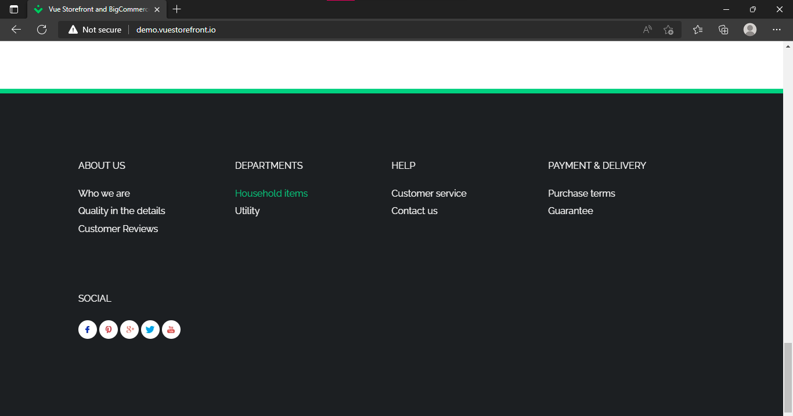

**Bug Id:** 16

**Title: “**Utility” link is not working in “Departments” in footer section.

**Reporting Date:** 24/07/2022

**Reporter:** Hamza Quraish

**Test Item:** Utility link

**Test Environment:** All Browsers/QA Environment

**Description:**

**Steps to reproduce:**

* Open [**http://demo.vuestorefront.io/**](http://demo.vuestorefront.io/)
* Go to the footer of the page.
* Click on “Utility” link Below Departments.

**Test Data Used:**

**Expected Result:** Utility page should open up.

**Actual Result:** Nothing happens on clicking “Utility” link

**Severity:** High

**Priority:** High

**Frequency:** Every time

**Status:** New

**Attachments:** 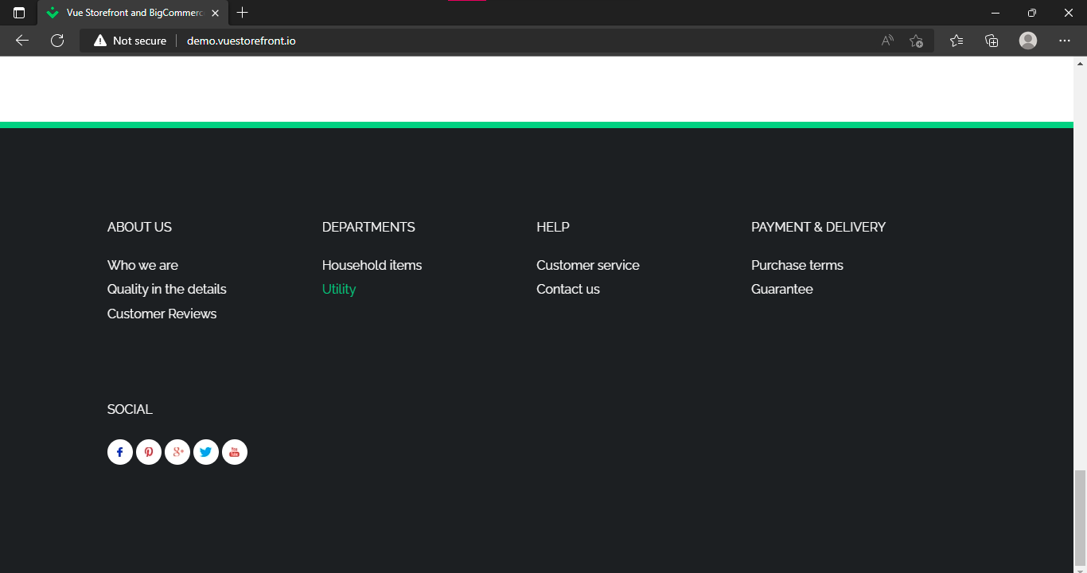

**Bug Id:** 17

**Title: “**Customer Service” link is not working in “Help” in footer section.

**Reporting Date:** 24/07/2022

**Reporter:** Hamza Quraish

**Test Item:** Customer Service link

**Test Environment:** All Browsers/QA Environment

**Description:**

**Steps to reproduce:**

* Open [**http://demo.vuestorefront.io/**](http://demo.vuestorefront.io/)
* Go to the footer of the page.
* Click on “Customer Service” link Below Help.

**Test Data Used:**

**Expected Result:** Customer Service page should open up.

**Actual Result:** Nothing happens on clicking “Customer Service” link

**Severity:** High

**Priority:** High

**Frequency:** Every time

**Status:** New

**Attachments:** 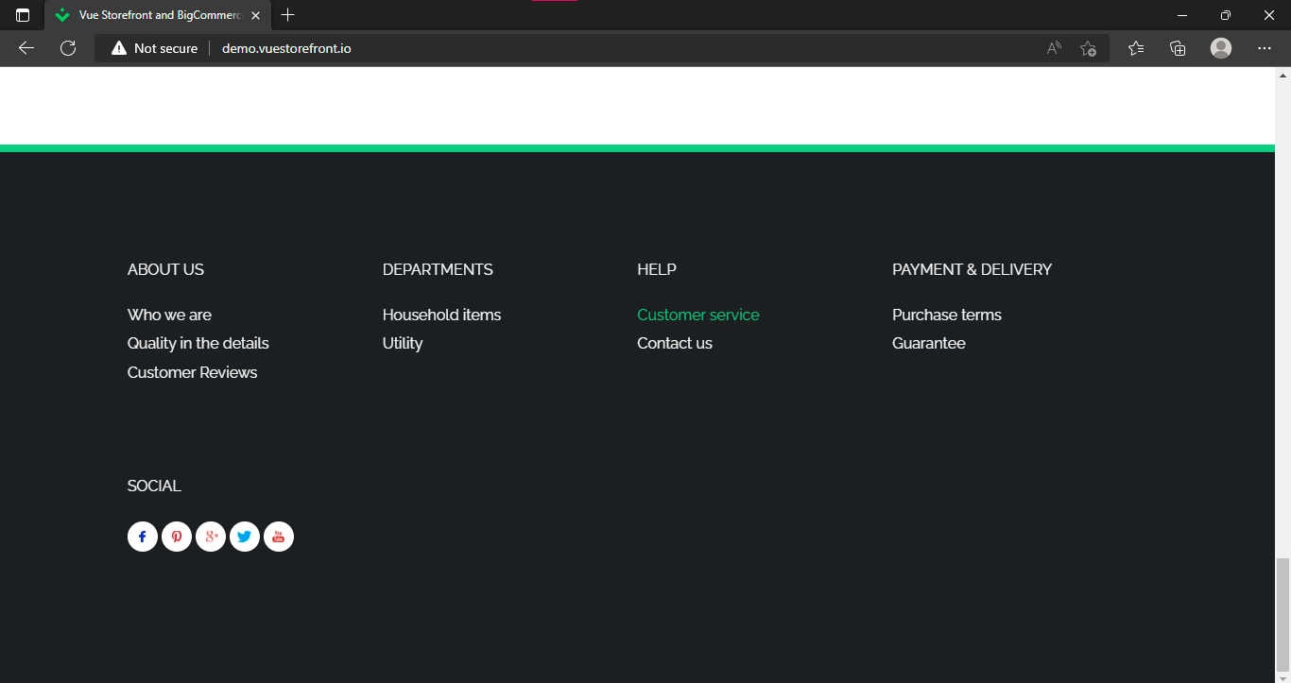

**Bug Id:** 18

**Title: “**Contact Us” link is not working in “Help” in footer section.

**Reporting Date:** 24/07/2022

**Reporter:** Hamza Quraish

**Test Item:** Contact Us link

**Test Environment:** All Browsers/QA Environment

**Description:**

**Steps to reproduce:**

* Open [**http://demo.vuestorefront.io/**](http://demo.vuestorefront.io/)
* Go to the footer of the page.
* Click on “Contact Us” link Below Help.

**Test Data Used:**

**Expected Result:** Contact Us page should open up.

**Actual Result:** Nothing happens on clicking “Contact Us” link

**Severity:** High

**Priority:** High

**Frequency:** Every time

**Status:** New

**Attachments:** 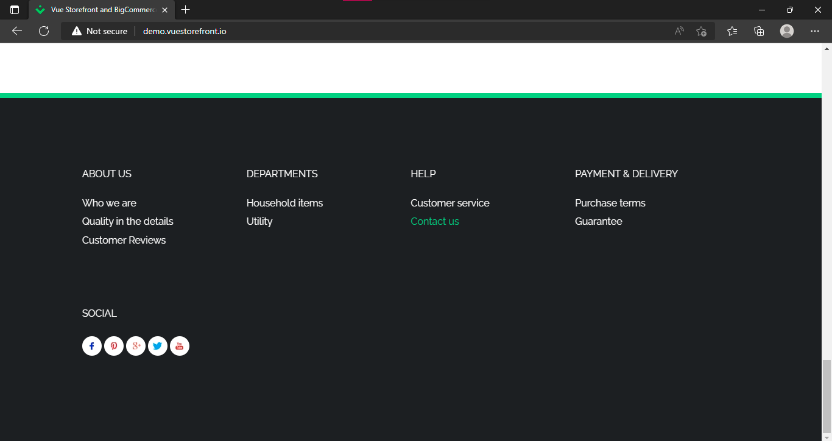

**Bug Id:** 19

**Title: “**Purchase Terms” link is not working in “Payment & Delivery” in footer section.

**Reporting Date:** 24/07/2022

**Reporter:** Hamza Quraish

**Test Item:** Purchase Terms link

**Test Environment:** All Browsers/QA Environment

**Description:**

**Steps to reproduce:**

* Open [**http://demo.vuestorefront.io/**](http://demo.vuestorefront.io/)
* Go to the footer of the page.
* Click on “Purchase Terms” link Below Payment & Delivery.

**Test Data Used:**

**Expected Result:** Purchase Terms page should open up.

**Actual Result:** Nothing happens on clicking “Purchase Terms” link

**Severity:** High

**Priority:** High

**Frequency:** Every time

**Status:** New

**Attachments:** 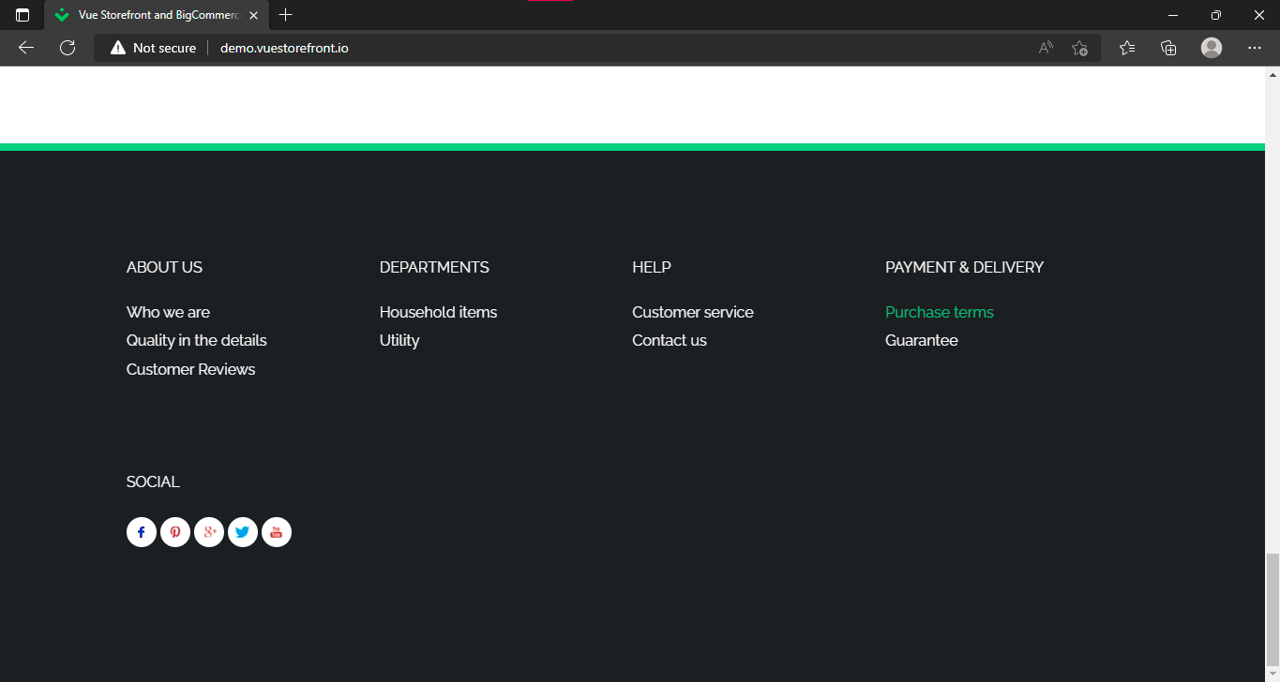

**Bug Id:** 20

**Title: “**Guarantee” link is not working in “Payment & Delivery” in footer section.

**Reporting Date:** 24/07/2022

**Reporter:** Hamza Quraish

**Test Item:** Guarantee link

**Test Environment:** All Browsers/QA Environment

**Description:**

**Steps to reproduce:**

* Open [**http://demo.vuestorefront.io/**](http://demo.vuestorefront.io/)
* Go to the footer of the page.
* Click on “Guarantee” link Below Payment & Delivery.

**Test Data Used:**

**Expected Result:** Guarantee page should open up.

**Actual Result:** Nothing happens on clicking “Guarantee” link

**Severity:** High

**Priority:** High

**Frequency:** Every time

**Status:** New

**Attachments:**

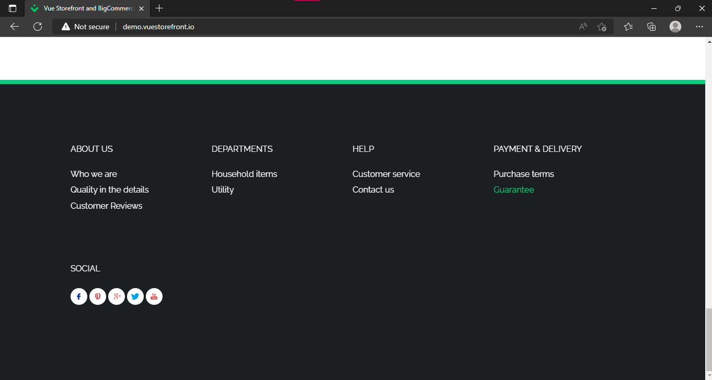

**Bug Id:** 21

**Title: “**Facebook” link is not working in “Social” in footer section.

**Reporting Date:** 24/07/2022

**Reporter:** Hamza Quraish

**Test Item:** Facebook

**Test Environment:** All Browsers/QA Environment

**Description:**

**Steps to reproduce:**

* Open [**http://demo.vuestorefront.io/**](http://demo.vuestorefront.io/)
* Go to the footer of the page.
* Click on “Facebook” link Below Social.

**Test Data Used:**

**Expected Result:** Facebook page should open up.

**Actual Result:** Nothing happens on clicking “Facebook” link

**Severity:** low

**Priority:** High

**Frequency:** Every time

**Status:** New

**Attachments:**

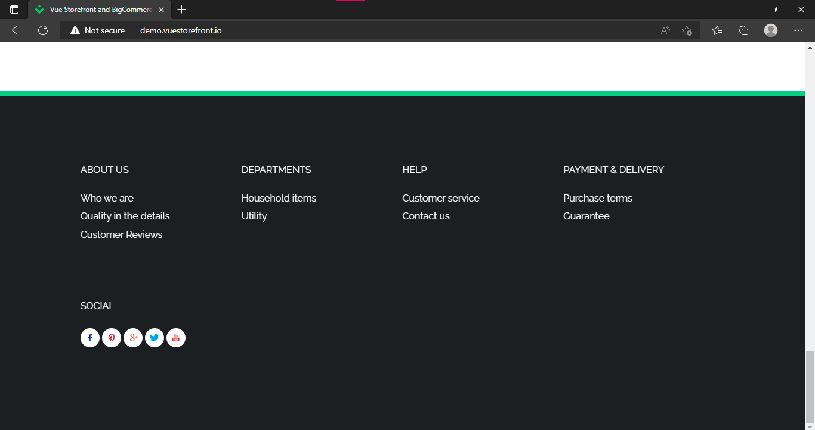

**Bug Id:** 22

**Title: “**Google plus” link is not working in “Social” in footer section.

**Reporting Date:** 24/07/2022

**Reporter:** Hamza Quraish

**Test Item:** Google plus link

**Test Environment:** All Browsers/QA Environment

**Description:**

**Steps to reproduce:**

* Open [**http://demo.vuestorefront.io/**](http://demo.vuestorefront.io/)
* Go to the footer of the page.
* Click on “Google plus” link Below Social.

**Test Data Used:**

**Expected Result:** Google plus page should open up.

**Actual Result:** Nothing happens on clicking “Google plus” link

**Severity:** low

**Priority:** High

**Frequency:** Every time

**Status:** New

**Attachments:**



**Bug Id:** 23

**Title: “**Twitter” link is not working in “Social” in footer section.

**Reporting Date:** 24/07/2022

**Reporter:** Hamza Quraish

**Test Item:** Twitter

**Test Environment:** All Browsers/QA Environment

**Description:**

**Steps to reproduce:**

* Open [**http://demo.vuestorefront.io/**](http://demo.vuestorefront.io/)
* Go to the footer of the page.
* Click on “Twitter” link Below Social.

**Test Data Used:**

**Expected Result:** Twitter page should open up.

**Actual Result:** Nothing happens on clicking “Twitter” link

**Severity:** low

**Priority:** High

**Frequency:** Every time

**Status:** New

**Attachments:**



**Bug Id:** 24

**Title: “**YouTube” link is not working in “Social” in footer section.

**Reporting Date:** 24/07/2022

**Reporter:** Hamza Quraish

**Test Item:** YouTube

**Test Environment:** All Browsers/QA Environment

**Description:**

**Steps to reproduce:**

* Open [**http://demo.vuestorefront.io/**](http://demo.vuestorefront.io/)
* Go to the footer of the page.
* Click on “YouTube” link Below Social.

**Test Data Used:**

**Expected Result:** YouTube page should open up.

**Actual Result:** Nothing happens on clicking “YouTube” link

**Severity:** low

**Priority:** High

**Frequency:** Every time

**Status:** New

**Attachments:**



**Bug Id:** 25

**Title:** Scroll bar is not available on “My Wishlist” to see all the items added to the wish list. Only two items are seeable.

**Reporting Date:** 24/07/2022

**Reporter:** Hamza Quraish

**Test Item:** My Wish List

**Test Environment:** All Browsers/QA Environment

**Description:**

**Steps to reproduce:**

* Open [**http://demo.vuestorefront.io/**](http://demo.vuestorefront.io/)
* Add items to the wish list
* Click on My Wishlist Icon

**Test Data Used:**

**Expected Result:** There should be a scroll bar to see all the items added to the wish list.

**Actual Result:** There is no scroll bar.

**Severity:** High

**Priority:** High

**Frequency:** Every time

**Status:** New

**Attachments:**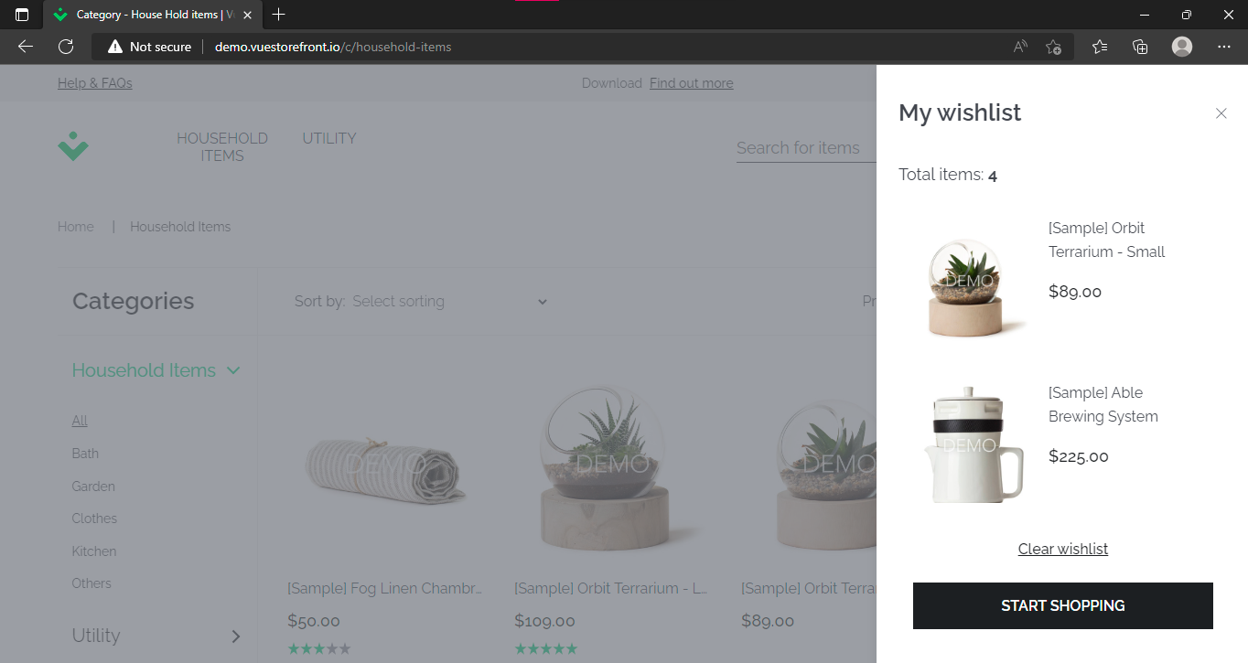

**Bug Id:** 26

**Title: “**Start Shopping” button is not working in “My Wishlist”.

**Reporting Date:** 24/07/2022

**Reporter:** Hamza Quraish

**Test Item:** Start Shopping button

**Test Environment:** All Browsers/QA Environment

**Description:**

**Steps to reproduce:**

* Open [**http://demo.vuestorefront.io/**](http://demo.vuestorefront.io/)
* Add items to the wish list
* Click on My Wishlist Icon
* Click on “Start Shopping” button

**Test Data Used:**

**Expected Result:** Items page should open up.

**Actual Result:** It just closes the “My wishlist”.

**Severity:** High

**Priority:** High

**Frequency:** Every time

**Status:** New

**Attachments:** 

**Bug Id:** 27

**Title:** Sort by **“**Price from high to low” is not working properly in “Household items” page.

**Reporting Date:** 24/07/2022

**Reporter:** Hamza Quraish

**Test Item:** Sort by select

**Test Environment:** All Browsers/QA Environment

**Description:**

**Steps to reproduce:**

* Open [**http://demo.vuestorefront.io/**](http://demo.vuestorefront.io/)
* Click on “Household items link”
* Click on select sorting
* Then select **“**Price from high to low” from drop down menu

**Test Data Used:**

**Expected Result:** All the items should be displayed in in an order of price from high to low.

**Actual Result:** Some products are not displayed in in an order of price from high to low.

**Severity:** High

**Priority:** High

**Frequency:** Every time

**Status:** New

**Attachments:** 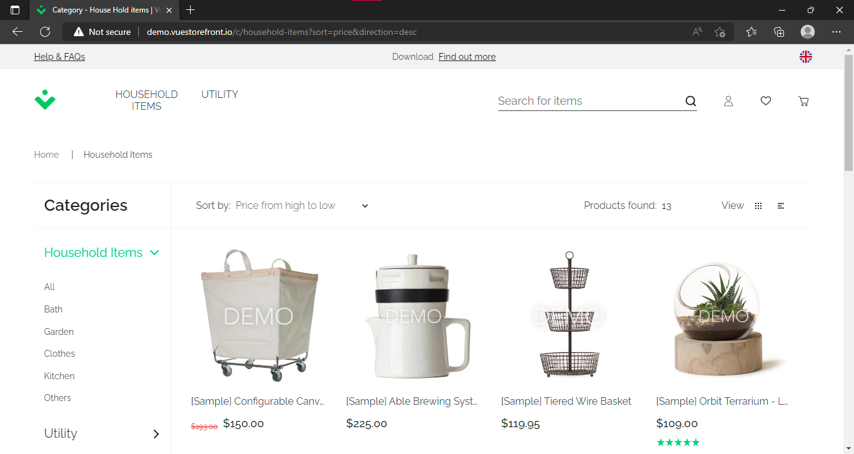

**Bug Id:** 28

**Title:** Sort by **“**Price from low to high” is not working properly in “Household items” page.

**Reporting Date:** 24/07/2022

**Reporter:** Hamza Quraish

**Test Item:** Sort by select

**Test Environment:** All Browsers/QA Environment

**Description:**

**Steps to reproduce:**

* Open [**http://demo.vuestorefront.io/**](http://demo.vuestorefront.io/)
* Click on “Household items link”
* Click on select sorting
* Then select **“**Price from low to high” from drop down menu

**Test Data Used:**

**Expected Result:** All the items should be displayed in an order of price from low to high.

**Actual Result:** Some products are not displayed in in an order of price from low to high.

**Severity:** High

**Priority:** High

**Frequency:** Every time

**Status:** New

**Attachments:** 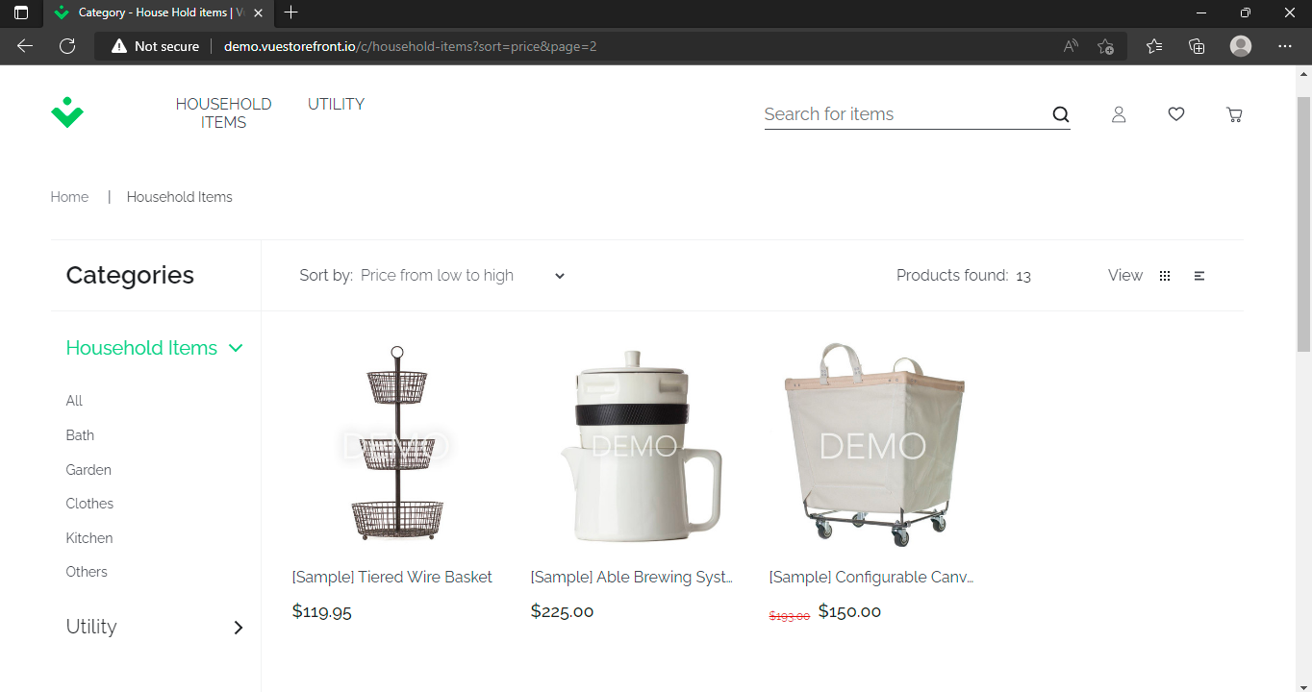

**Bug Id:** 29

**Title:** In bath category some irrelevant items are displayed in “Household items” page.

**Reporting Date:** 24/07/2022

**Reporter:** Hamza Quraish

**Test Item:** Household Items Categories

**Test Environment:** All Browsers/QA Environment

**Description:**

**Steps to reproduce:**

* Open [**http://demo.vuestorefront.io/**](http://demo.vuestorefront.io/)
* Click on “Household items link”
* Click on “Bath” in household items categories

**Test Data Used:**

**Expected Result:** All the bath items should be displayed.

**Actual Result:** Some Kitchen items are also displayed in bath category.

**Severity:** High

**Priority:** High

**Frequency:** Every time

**Status:** New

**Attachments:** 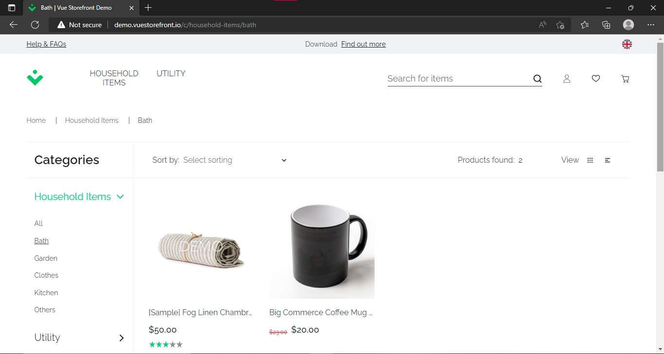

**Bug Id:** 30

**Title: “**Size guide” link is not working in any Product

**Reporting Date:** 24/07/2022

**Reporter:** Hamza Quraish

**Test Item:** Size guide link

**Test Environment:** All Browsers/QA Environment

**Description:**

**Steps to reproduce:**

* Open [**http://demo.vuestorefront.io/**](http://demo.vuestorefront.io/)
* Click on “Household items link”
* Click on any product
* Click on “Size guide” link

**Test Data Used:**

**Expected Result:** Relevant size guide of the product should be displayed.

**Actual Result:** Nothing happens on clicking the “Size guide” link.

**Severity:** High

**Priority:** High

**Frequency:** Every time

**Status:** New

**Attachments:** 